# Deep Analysis

### Service 1

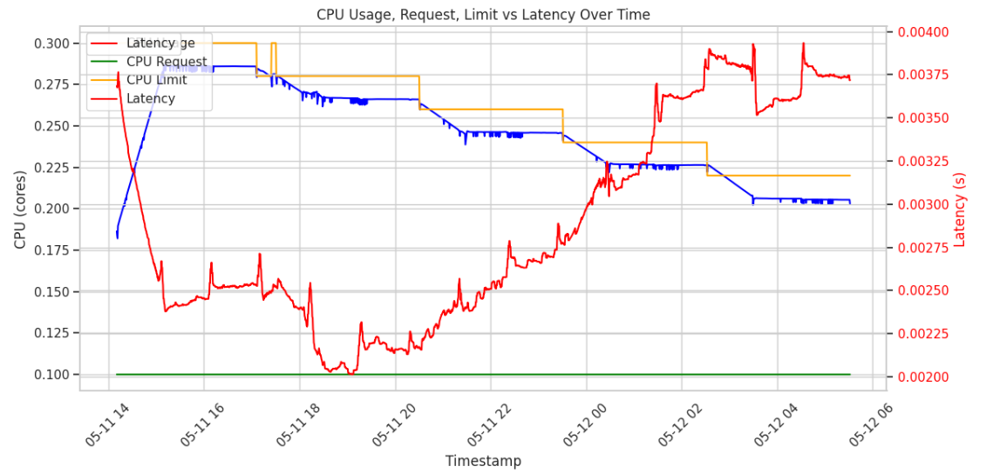

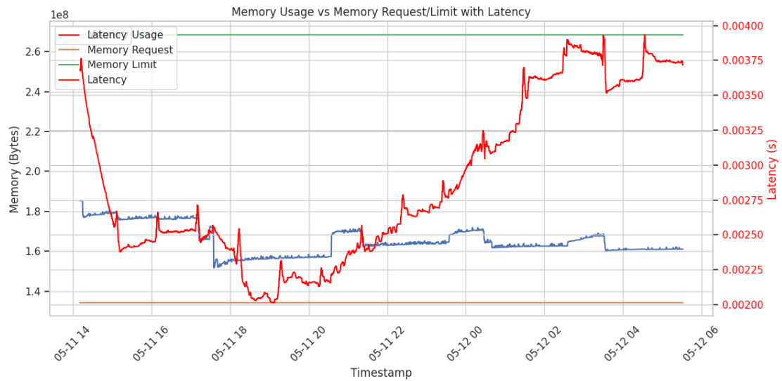

#### Latency Spikes Throughout the graph

1. CPU Throttling & Scheduling Delays

* As we reduce the CPU limit, Kubernetes enforces it strictly.
* When the application demands more CPU than allowed, it gets throttled.
* This causes:
  + Thread queuing
  + Context switching delays
  + Slower request handling
* Latency spikes, even if usage appears “low.” It’s not that the app doesn’t need CPU—it’s being denied it.

1. Garbage Collection (GC) Delays in Java

* Your service is Java-based, meaning GC plays a major role in runtime latency.
* GC requires CPU time. When CPU is throttled:
* GC runs less frequently or for longer durations.
* Heap space fills up -> **minor GC becomes major GC** -> latency spikes.
* Threads may pause during GC (especially with Stop-The-World events).
* Intermittent but large latency spikes, especially when memory usage increases or GC is delayed.

1. Jitter from Background Services

* Java services may have background threads for:
  + Logging
  + Health checks
  + Internal thread pools
* These compete with the main request-processing thread, especially when CPU is limited.
* Any spike in background task CPU demand can slow down response latency.
* Short-lived but frequent latency spikes, seen as jitter.

1. Thread Pool Saturation

* Java web services often use thread pools (e.g., Tomcat, Jetty).
* If CPU is insufficient, request threads:
  + Take longer to process
  + Build up in the queue
* Eventually, the queue becomes saturated, forcing:
  + Rejected requests
  + Slow throughput -> high latency
* Latency spikes increase in magnitude the longer CPU remains under-provisioned.

#### Dynamic Load or External Triggers

* We are sending multiple parallel requests (e.g., 10/s from a client).
* If there’s even slight load imbalance, one pod may receive a burst.
* Combined with CPU limits, this causes temporary overload -> spike.
* Spikes appear even if average load is low, due to micro-bursts.

1. Heap Memory Pressure -> CPU Demand Loop

* When memory usage increases, the JVM:
  + Allocates more memory
  + Increases GC frequency
  + GC needs CPU -> which is already constrained
* This forms a feedback loop: memory increase -> GC -> CPU -> latency -> more memory usage…
* Repeated latency spikes as heap usage and CPU limits fight each other.

#### Latency Drop at 05-11 20

* This is not a natural decline over time but a sharp, step-like drop.
* At this time increased CPU limits, the container:
  + Stopped being throttled
  + Could serve requests faster
  + GC runs completed faster, reducing pauses
  + Latency dropped quickly
* Drop in CPU usage % may seem counterintuitive but indicates more headroom was available, so no throttling.
* With higher limits, actual CPU demand is met without delay -> lower latency.

#### Latency Drop at 05-12 04

1. Just-In-Time (JIT) Compilation Kicked In

* Java JIT Compiler (HotSpot) is known to:
  + Compile "hot" methods (those called frequently) at runtime into optimized native code.
  + This often happens after some sustained activity - like several invocations.
* Latency drops suddenly after optimized code replaces interpreted bytecode.
* The drop near 05-12 04:00 suggests that JIT optimizations became active, improving response time without needing more CPU.

#### Why Latency is increasing after a the above drop

1. CPU Limit Throttling Reasserts Itself

* This is common in long-running Java services, and it can result from a combination of dynamic runtime factors:
  + Even with optimized bytecode, we’re still operating under a constrained CPU limit.
  + Especially during peak processing or multiple requests, the OS scheduler throttles the container, leading to increased latency again.

1. Garbage Collection Pressure Builds Up Again

* JIT optimizations often allocate more short-lived objects as they inline and unroll loops.
* This can cause:
  + More frequent young GCs
  + Occasional longer full GCs

1. Then internal request queues may grow again, increasing latency.

### Service 1 - Only Memory Limit Reduction

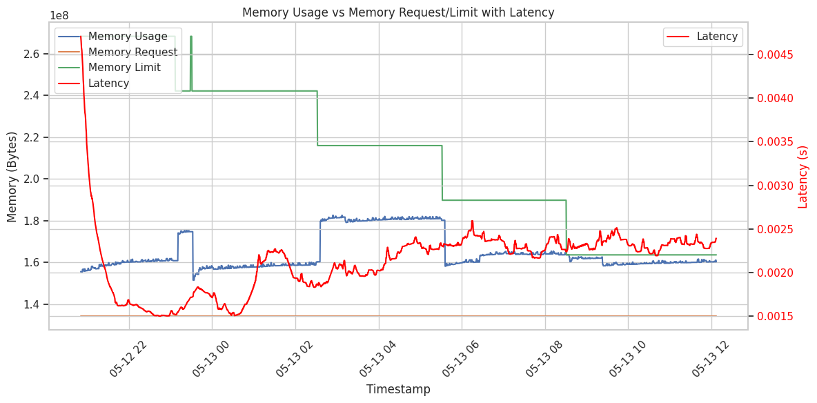

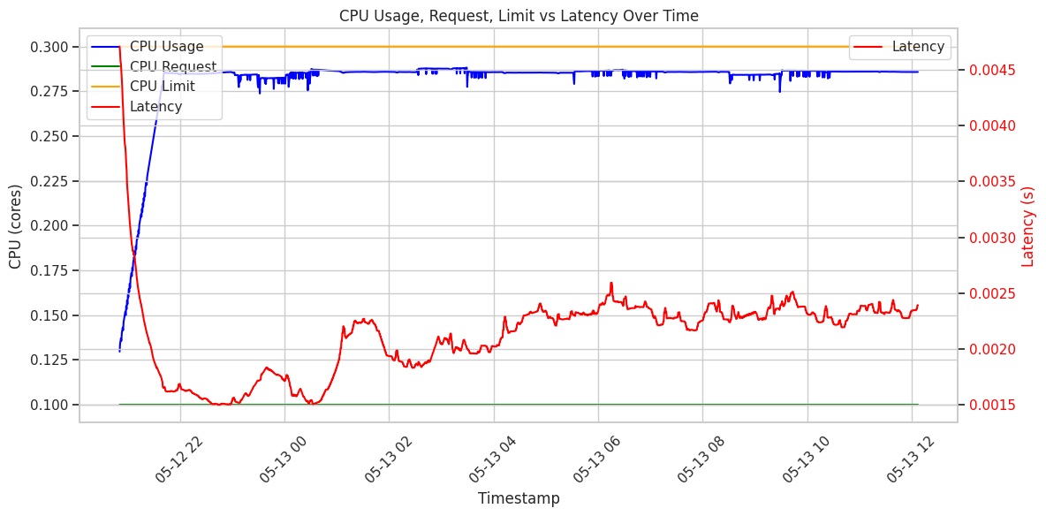

* After each memory reduction:
  + No sudden latency spike.
  + However, **l**atency rises gradually as memory is reduced.
* Interpretation:
  + JVM doesn't immediately break under low memory.
  + But less heap space **->** more frequent GC **->** longer GC pauses -> gradual latency increase.
* This fits classic Java GC behavior:
  + The heap is small and GC has to work harder to reclaim memory, latency increases due to more frequent and longer GC pauses.
* CPU usage remains flat.
* So latency increases despite plenty of CPU, again pointing to memory pressure as the source.

Why there is a higher memory usage from 05-13 02 to 05-13 06 more than other places?

1. More Complex Requests (Data-Dependent Workload)

* This indicates input data changed during this time, likelarger numbers - the app will have:
  + Built larger in-memory structures (arrays, strings, logs, etc.).
  + Run more iterations or used recursive methods.
  + Consumed more heap space per request.

1. JVM Memory Fragmentation or Delayed GC

* During this window, GC may not have run aggressively - possibly to avoid long pauses.

* The memory spike between 05-13 02 and 05-13 06 likely results from accumulating memory pressure due to tight memory limits and temporarily ineffective GC cycles, possibly worsened by complex input data or background activity.

### Service 1 - Both Resource Limits Reduction

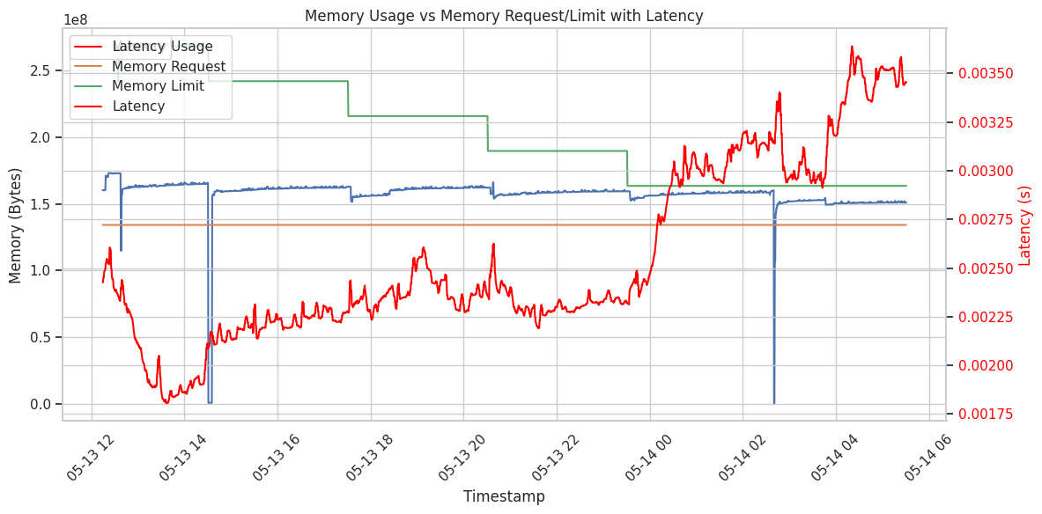

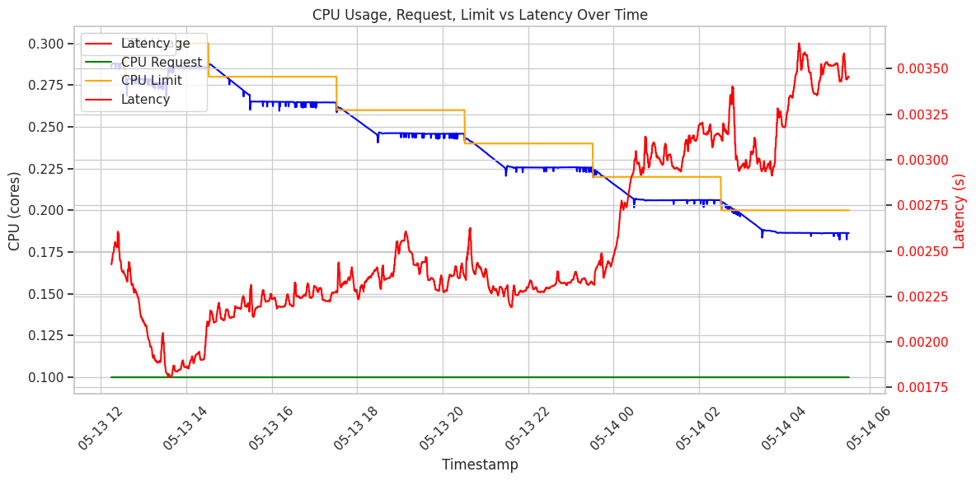

1. Latency Trends Are Closely Tied to CPU Limit Reductions

* CPU usage hovers just below the CPU limits & some places, there is throttling happens.
* As CPU limits are gradually reduced, CPU usage tracks closely with limits (indicating saturation)..
* Once the CPU becomes constrained, latency begins to rise more sharply:
  + Latency begins its ascent.
  + Latency increases significantly, matching the drops in CPU limit.
* Latency is CPU-bound - verification of primes (an intensive computational task) slows down as CPU capacity shrinks.
* CPU throttling introduces queuing and scheduling delays, especially under constant load.

2. Memory Pressure Is Secondary, but Still Influential

From the top plot:

* Memory usage is relatively flat or slowly rising and always stays below the limit.
* No major GC stalls or sudden drops - suggests JVM is coping well.

However:

* Small upward drift in latency aligns with minor increases in memory usage.
* Memory is not the main bottleneck, but:
  + Reduced memory causes more frequent GC.
  + GC cycles may slightly raise latency, but not spike it sharply.
* JVM is well-tuned and is respecting container constraints, but tight limits + CPU contention = slower object promotion & cleanup.

3. Sudden Latency Escalation After 05-14 00

* Both CPU usage and memory usage start showing more frequent upward fluctuations.
* Latency rises steeply even though memory usage doesn’t.
* We're reaching the performance tipping point:
  + JVM threads are competing for CPU cycles, increasing latency.
  + Even small fluctuations in workload or GC could cause request delays.

Why Focus on CPU?

* Even though CPU and memory limits are reduced simultaneously in our plots, we can isolate their effects by analyzing the behavior of usage metrics relative to their limits.

1. Memory Usage vs. Memory Limit

* In the top plot, memory usage consistently remains below the memory limit.
* Even after multiple reductions, memory usage does not approach the limit, and there's no thrashing, OOM errors, or GC-induced latency spikes visible.
* No correlation between memory drops and latency increases.
* Memory is not the bottleneck.

2. CPU Usage vs. CPU Limit

* In the bottom plot, CPU usage tracks very closely with the CPU limit.
* After each CPU limit drop:
  + CPU usage saturates the new limit.
  + Latency shows a clear, immediate upward slope.
* Especially after ~05-14 00, CPU usage is near the limit and latency spikes significantly.
* CPU limit reductions are directly constraining the workload, resulting in queue buildup and latency spikes.

3. Latency Spikes Align with CPU Saturation

* If memory were the root cause, we'd expect:
  + Sudden drops in memory usage.
  + Spiky GC behavior (which would show as dips or resets in memory usage).
  + Erratic latency jumps.
* Instead, latency steadily increases in tandem with CPU usage saturation, not with memory dynamics.
* Latency grows as threads are CPU-throttled, not due to memory contention.

4. Workload Nature - CPU-Bound

* This is a prime number verification Java service:
  + This is a CPU-intensive workload by nature (heavy math, little memory allocation).
  + Memory is mostly static - the CPU does the heavy lifting.
  + Memory drops are mostly JVM heap reductions, which don’t immediately impact throughput if still above usage.
* The nature of the workload further confirms CPU bottleneck dominates.

What If It Were Memory?

We’d see something like this if memory were the limiting factor:

* Memory usage hits or flutters near the limit.
* JVM triggers frequent GCs -> memory usage dips.
* Latency spikes right after memory drops.

But in our plots, memory usage is steady or rising, and latency doesn’t spike with memory behavior.